Event: Varsity Football
Opponent: Ankeny Centennial
Date: September 27th, 2024
Kickoff: 7:00pm

This mailing contains important information that will help everything run smoothly and ensure everyone has a great time. We look forward to a relaxing and enjoyable evening of games and camaraderie.

SIDELINE ACCESS
Duke Williams stadium is a controlled environment on Friday night and access to the field will be limited.

We would ask that you prepare a detailed list of individuals with name and title that you wish to have access to your sideline on Friday night. We will utilize your printed game roster for players and coaches, however, if you have other coaches, manager, administrators, photographers and students you want to have access to the field we will need that list in advance.

Please note that those on your list are limited to your sideline and become the responsibility of your team’s management at all times.

Please email at least 2 days in advance to: Kimberly.smith@dmschools.org

EVENT MANAGEMENT – OPPONENT INFORMATION
Bus Parking: Available in the lot South of the stadium or at East High School.
Team Escort: J.R. Randall (641-680-7604)
Locker Room Assignment: Visitors will be assigned to the Grandview locker rooms which are directly North of the visiting bleachers. Players/Coaches may enter through the gate directly East of the locker room (See attached map).
Valuables: While Des Moines East is confident in the security of valuables at the Stadium, we do encourage teams to take a bag of valuables to the sideline with them.
Sideline: You will be located on the East side of the stadium. Fans will enter through the ticket booth located in the pavilion and then cross over to their bleachers.
Sideline Access: Sideline access is limited to the list of individuals you identify in your official traveling party. No additional entry is permitted.
Press Box: You will be allotted space in the press box on the East side (visitor’s sideline) of the stadium. You are responsible for your own on-field communication systems.
Additional: ONLY CLEAR BAGS ARE ALLOWED.
Your team bus will drop players/coaches off on the East side of the stadium near the Grandview locker room. Your bus may park in the grass directly behind the East bleachers.
Visiting fans will use the ticket book on the East side of the stadium
Please pass on my contact information to your coaches and bus driver. Have them text or call when they are close, and we’ll make arrangements to have someone there to let them in the locker room. J.R. Randall 641-680-7604
Ticket Link: Varsity Football - Urbandale at D.M. East
Concessions: Cash only

EVENT MANAGEMENT – OPPONENT INFORMATION
PREGAME
90:00 Field ready for teams
60:00 Ticket Gates open
13:00 Teams leave the field / Coin toss North endzone area
12:00 Band takes the field
9:30 National Anthem
6:00 Teams return to the field
2:00 Mock coin toss midfield
0:00 Kickoff

HALFTIME
20:00 Field open for the band
18:00 Halftime Performance
11:45 Band march off
9:00 Homecoming Royalty
3:00 Field Ready for Teams

EVENT MANAGEMENT – OPPONENT INFORMATION
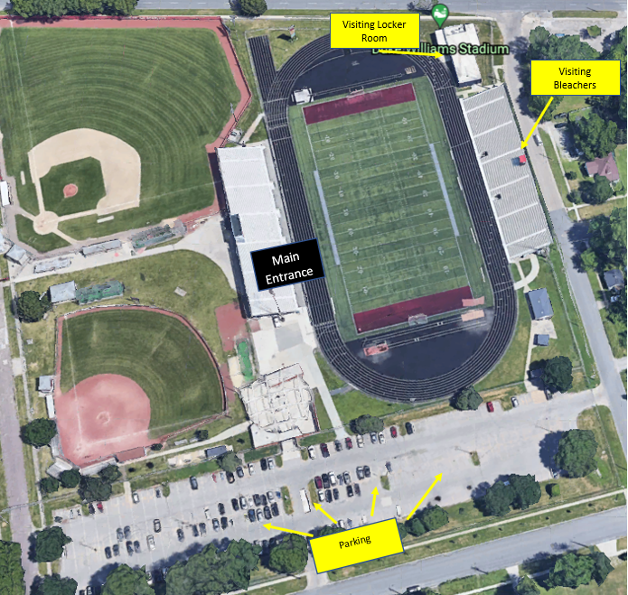
Visitor Gate

EVENT MANAGEMENT – OPPONENT INFORMATION
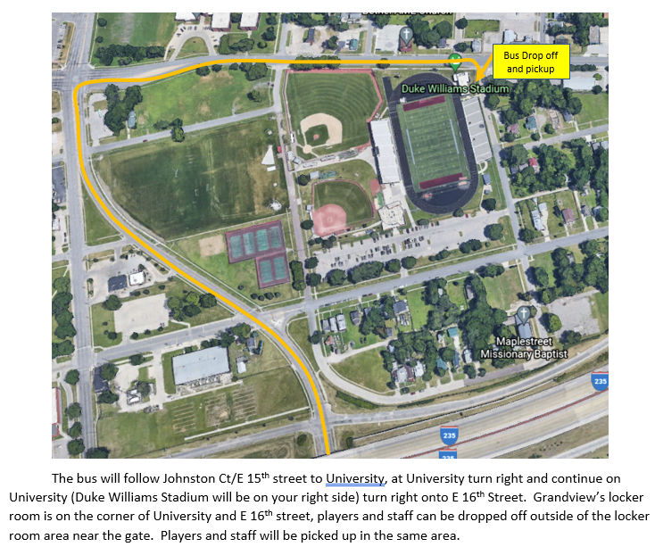

EVENT MANAGEMENT – IN GAME RULES OF NOTE
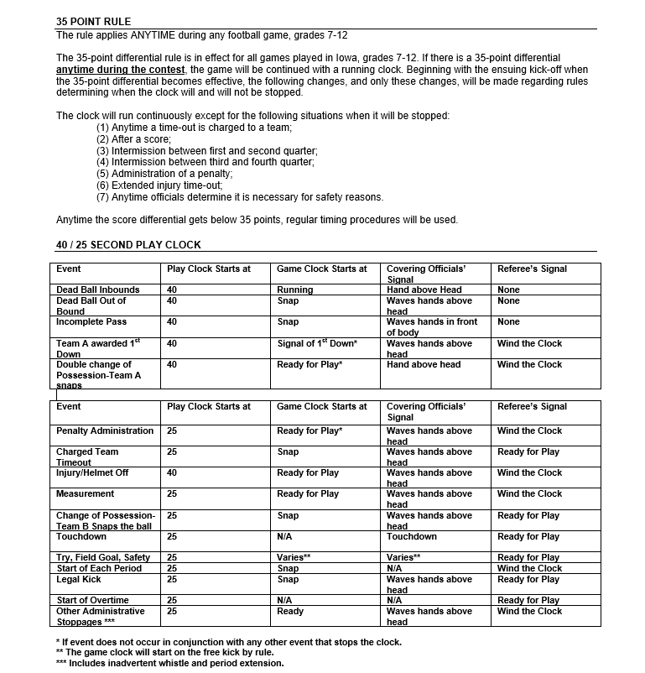

EVENT MANAGEMENT – PERSONNEL
Management & Administration
Athletic Staff
Director of Activities | J.R. Randall
Assistant Activity Director  Assistant Activity Director | Lowell Long  Kyle Reeping
Arrival Time | 4:15pm
Location | SW Stadium
Special Instructions | None
Administrator(s) | Jill Versteeg/HS Admin Team
Arrival Time | 5:30pm Main Gate Administrator
 | 6:00pm All other administrators
Special Instructions | Administrator at Main gate through the end of Q3
Security
Security | Des Moines Police Department  Best Security (5)
Arrival Time | Officers (2) at Scarlet walk at 5:00pm
 | Officers (4) in uniform at 6:00pm
 | DMPS Public Safety (1)
Gate Management
Ticket information
Ticket Prices | $7.00 Electronic / $8.00 Cash
Acceptable Passes | Senior / East Internal Passes / Administrator Passes / Bound Passes
Special Instructions | Everyone entering the facility must have a ticket voucher unless listed on the pass gate list  Tickets are to be used for all paying customers
Main Gate
Coordinator | J.R. Randall
Home Gate  5:30pm – 8:30pm | Gabriele Albrecht, Jennifer Medina, Nathan Opheim, Vidal Spaine, Tracey Leech, Joleen Weller
Visitor Gate
Arrival Time | 5:30pm
EVENT MANAGEMENT – PERSONNEL
Support Staff
Visitor North Gate Control | Best Security
Visitor South Gate Control | Best Security
Home North Gate Control  Home South Gate Control | Best Security  Best Security
Special Instructions
Officials
Officials’ Escort | J.R. Randall
Locker Room Assignment | Officials Locker Room – Grandview JV Locker Room
Special Instructions | None
Opponents
Opponents Escort | J.R. Randall / Lowell Long
Locker Room Assignment | Grand View Varsity Locker Room
Special Instructions
Press Box
Announcer | Dan Pardock
Clock Operator | Sam Juhl
Play Clock | Ken Morton
Spotter
Special Instructions | Clock Operators: Arrive 6:00pm to meet with officials  Announcer: Arrive 6:00pm
Chain Crew
Personnel | Bob Bagley, Evan Smith, Monty Harrington, Brian Koch
Special Instructions | On field no later than 45 minutes before kickoff to meet with officials
Athletic Trainer
Trainer | Brittany Carlson
Location | DM East High School Sideline
Special Instructions | Available for both teams during competition

EVENT MANAGEMENT – PERSONNEL
Concession – Main
Supervisor | Kim Smith
Group/Activity
Location | Main Concessions Stand
Arrival Time | 5:30pm
Special Instructions
Officials’ Information
Event Location | Duke Williams Stadium
Parking | Parking is available South of the stadium.
Officials Escort | J.R. Randall / Lowell Long
Locker Room Assignment | Officials Locker Room – Grand View JV Locker Room  Enter the main gate of the stadium and your escort will take you from there
On Field Microphone | DM East does not use an On-Field Microphone System
Officials’ Name(s) | Referee – Craig Van Vark  Umpire – Kyle Ward  Head Linesman – Daniel Zegers  Line Judge – Todd Roorda  Back Judge – Matthew Paschal
Special Instructions | Additional water breaks are at the discretion of Home Management in consultation with the Officials and Opponent

EVENT MANAGEMENT – OFFICIALS

CONTACT INFORMATION
Des Moines East High School
J.R. Randall – Director of Activities and School Equity
Office: | (515) 242-7945
Cellular: | (641) 680-7604
Kyle Reeping – Assistant Activities Director
Cellular: | (507) 696-0824
Lowell Long – Assistant Activities Director
Cellular: | (515) 988-1038
Jill Versteeg – Des Moines East – Principal
Office: | (515) 242-7758
Cellular: | (515) 979-8983
Brittany Carlson – Athletic Trainer
Cellular: | (515) 577-3291

